# CS539 Final report

Advanced Predictive Modeling for Healthcare and Stock Market

Team 4: Omnia Abouhassan, Nate Hindman, Tanveer Kaur, Sepideh Sedghi, Yilu Yang, Haoyang An

### Introduction

Our goal is to evaluate the effectiveness of different machine learning models (regression vs. classification) across diverse prediction tasks. We used two datasets: one for diabetes diagnosis and another for stock price prediction.

### Problem Definition

The problem we're tackling is to determine which type of machine learning model—regression or classification—is more suitable for different types of prediction tasks. Specifically, we want to see how well these models perform on predicting whether a patient has diabetes and forecasting stock prices.

### Team Division

Our team of six divided into two groups:

1. Team 1: Focused on applying regression methods to stock market datasets.
2. Team 2: Focused on applying classification methods to medical datasets (diabetes diagnosis).

## Healthcare Data Analysis and Predictive Modeling - Team 2

Our mission was to predict diabetes using various classification methods and compare their effectiveness. We used a dataset from Kaggle, which includes several health metrics and the outcome of diabetes diagnosis. t consists of 768 instances with the following features:

* Pregnancies: Number of times pregnant
* Glucose: Plasma glucose concentration after 2 hours in an oral glucose tolerance test
* BloodPressure: Diastolic blood pressure (mm Hg)
* SkinThickness: Triceps skin fold thickness (mm)
* Insulin: 2-Hour serum insulin (mu U/ml)
* BMI: Body mass index (weight in kg/(height in m)²)
* DiabetesPedigreeFunction: A function that scores likelihood of diabetes based on family history
* Age: Age in years
* Outcome: Target variable (0 = No Diabetes, 1 = Diabetes)

The dataset presented several data quality challenges:

* Zero values in features where zeros are not biologically plausible (Glucose, BloodPressure, SkinThickness, Insulin, BMI)
* Class imbalance (approximately 65% non-diabetic, 35% diabetic cases)
* Missing values that needed appropriate imputation

### 1. Logistic Regression Implementation

##### Data Preprocessing: Initial data preprocessing revealed significant data quality issues:

* 80 outliers were removed using z-score filtering
* Zero values were converted to NaN in biologically implausible contexts:
  + Glucose: 5 zeros (0.7%)
  + BloodPressure: 35 zeros (4.6%)
  + SkinThickness: 227 zeros (29.6%)
  + Insulin: 374 zeros (48.7%)
  + BMI: 11 zeros (1.4%)

##### Feature Engineering: I enhanced the predictive power of the model by creating domain-specific features:

* Categorical variables: BMI categories (Underweight, Normal, Overweight, Obese) and Age groups (Young, Middle-aged, Senior)
* Interaction terms: Glucose×BMI, Age×Insulin, BloodPressure×BMI
* Ratio features: Glucose-to-Insulin ratio, HOMA-IR (Homeostatic Model Assessment for Insulin Resistance)
* Polynomial features: Squared terms for Glucose, BMI, and Age
* Logarithmic transformations: Log transformations of Glucose, Insulin, and SkinThickness

##### Feature Selection: I applied multiple feature selection techniques to identify the most predictive variables:

* RFECV (Recursive Feature Elimination with Cross-Validation) selected 12 features including BloodPressure, SkinThickness, Insulin, Age, and several engineered features
* Mutual Information identified 15 informative features with HOMA-IR, Log_Glucose, and Glucose_Squared ranking highest
* LASSO (L1 regularization) selected 13 features focusing on Glucose, BloodPressure, and interaction terms

The RFECV-selected features were used for further modeling: ['BloodPressure', 'SkinThickness', 'Insulin', 'Age', 'Glucose_BMI_Interaction', 'Age_Insulin_Interaction', 'Glucose_to_Insulin_Ratio', 'HOMA-IR', 'Glucose_Squared', 'Age_Squared', 'Log_SkinThickness', 'Age_Group_Middle-aged']

##### Class Imbalance Handling: I evaluated multiple resampling techniques to address the class imbalance problem:

* SMOTE: Synthetic Minority Over-sampling Technique (F1: 0.6923)
* Borderline SMOTE: Focused on boundary examples (F1: 0.6852)
* ADASYN: Adaptive Synthetic Sampling (F1: 0.6964)
* SMOTE+Tomek: Combined oversampling and cleaning (F1: 0.6916)
* SMOTE+ENN: Enhanced Nearest Neighbors cleaning (F1: 0.6880)

ADASYN achieved the highest F1 score (0.6964) and was selected for the final model.

##### Threshold Optimization: A classification threshold analysis was performed to balance precision and recall:

* The optimal threshold was determined to be 0.55 (instead of the default 0.50)
* At this threshold, the model achieved better balance between false positives and false negatives as shown in the confusion matrix (72 true negatives, 38 true positives, 27 false positives, 17 false negatives)

##### Model Calibration: I evaluated model calibration to assess probability reliability:

* The initial model showed mild miscalibration (Brier score: 0.1938)
* Model calibration improved prediction reliability for risk assessment
* Calibrated model: Accuracy 0.73, Precision 0.64, Recall 0.58 (vs uncalibrated: Accuracy 0.71, Precision 0.58, Recall 0.69)

##### Model Evaluation: The logistic regression model achieved:

* Accuracy: 0.71
* Precision: 0.58
* Recall: 0.69
* F1 Score: 0.63
* AUC: 0.79
* Average Precision: 0.68

##### Interpretability Analysis: LIME (Local Interpretable Model-agnostic Explanations) analysis revealed:

* For non-diabetic cases: Low insulin levels, low skin thickness, and younger age were protective factors
* For diabetic cases: Higher age, age-insulin interaction, and log-transformed skin thickness were risk factors

Partial dependence plots showed:

* Log_SkinThickness: S-shaped relationship with steep increase in diabetes risk at mid-range values
* Age: Nearly linear positive relationship with diabetes risk
* Age_Insulin_Interaction: Linear positive relationship, highlighting how insulin resistance risk increases with age

## 2. Neural Network Architectures

## Four different architectures were implemented:

1. Multi-Layer Perceptron (MLP): A standard feedforward neural network with three hidden layers (128→64→32 neurons), batch normalization, and dropout layers.
2. Deep Neural Network (DNN) with Skip Connections: Similar to MLP but incorporates skip connections to improve gradient flow and training stability.
3. Convolutional Neural Network (CNN): Applies 1D convolutions to tabular data, treating features as a sequence with potential local patterns.
4. Recurrent Neural Network (RNN): Uses SimpleRNN layers to potentially capture sequential relationships in the data.



## 3. Performance Comparison

### Model Metrics

|  |  |  |  |  |  |
| --- | --- | --- | --- | --- | --- |
| Model | Accuracy | AUC | Precision | Recall | F1 Score |
| MLP | 0.7403 | 0.8307 | 0.6296 | 0.6296 | 0.6296 |
| DNN | 0.7273 | 0.8231 | 0.6579 | 0.4630 | 0.5435 |
| CNN | 0.7403 | 0.8254 | 0.6400 | 0.5926 | 0.6154 |
| RNN | 0.7532 | 0.8096 | 0.6481 | 0.6481 | 0.6481 |

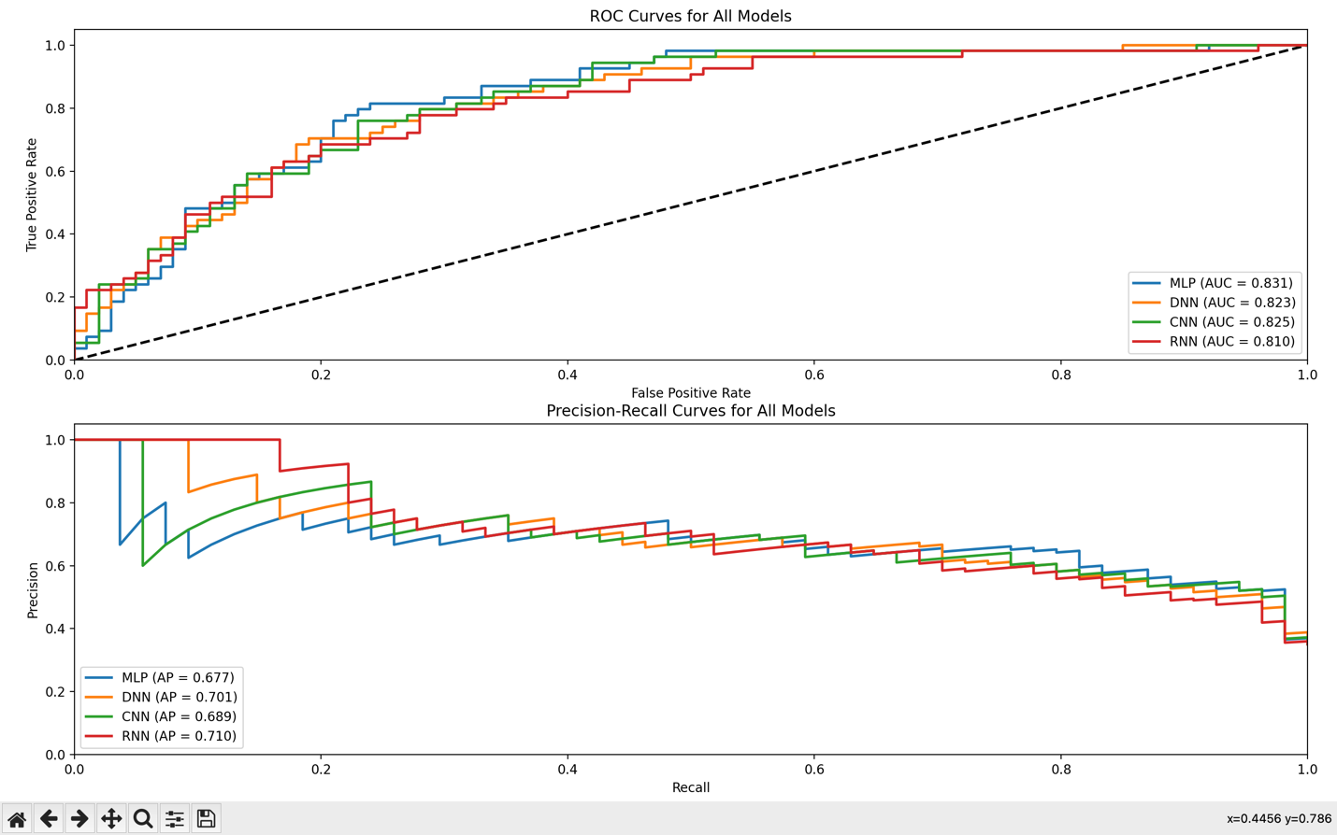

### Key Findings

1. Best Overall Performance: The RNN model achieved the highest accuracy (75.32%) and balanced F1 score (0.6481).
2. Discrimination Ability: The MLP had the highest AUC (0.8307), indicating better ranking of positive vs. negative cases.
3. Precision vs. Recall: The DNN model showed higher precision (0.6579) but poor recall (0.4630), making it less suitable for a screening tool where missing positive cases is costly.
4. Simplicity vs. Performance: The simpler MLP architecture performed competitively with more complex models, suggesting diminishing returns from architectural complexity for this dataset.

## 4. Training Dynamics

### MLP

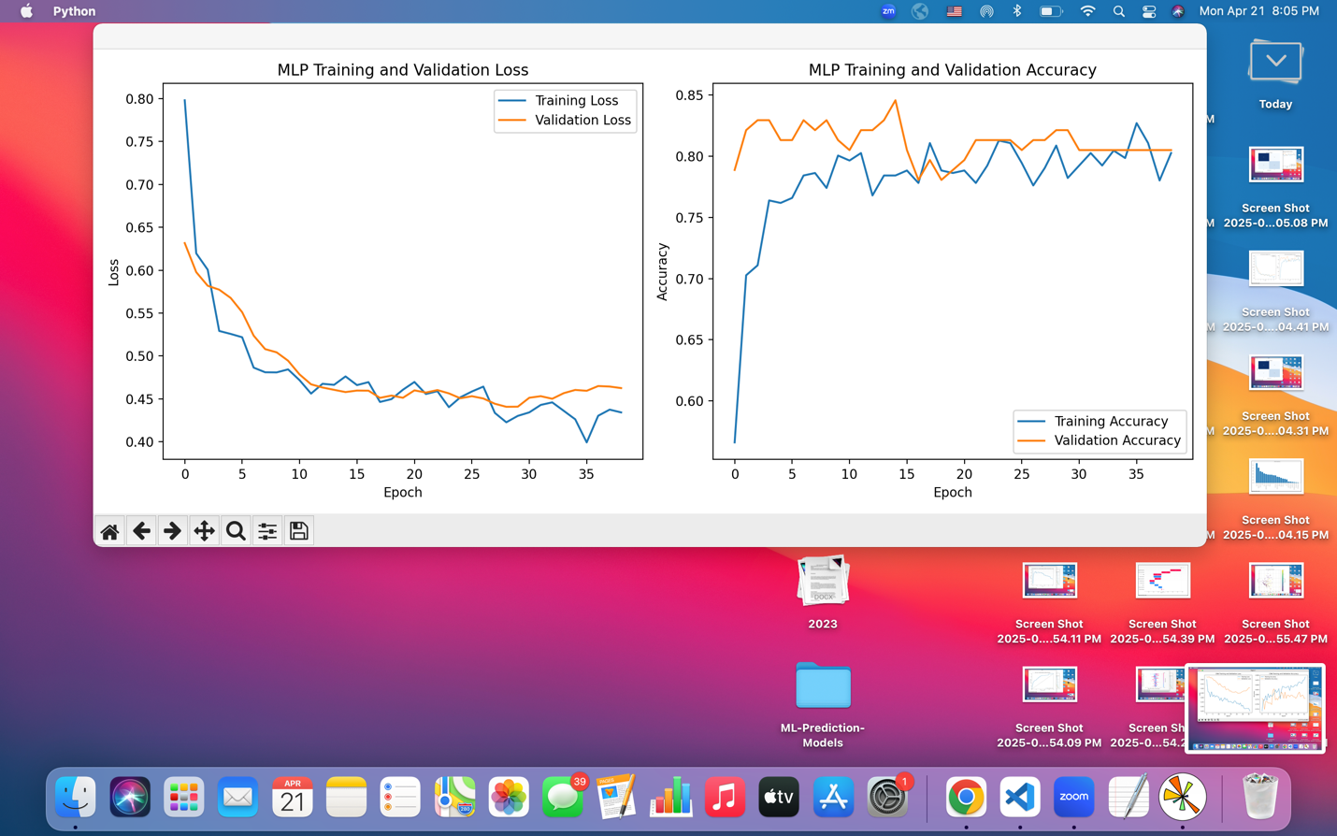

The MLP showed stable convergence with validation accuracy consistently higher than training accuracy, indicating good generalization without overfitting.

### CNN

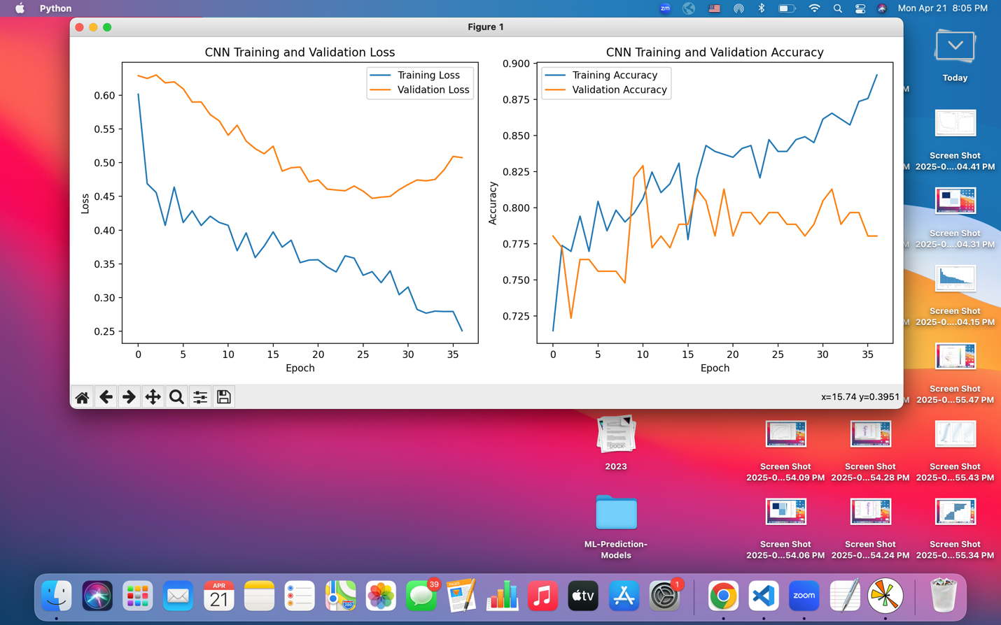

The CNN exhibited signs of overfitting as training progressed, with training accuracy continuing to increase while validation accuracy plateaued.

### RNN

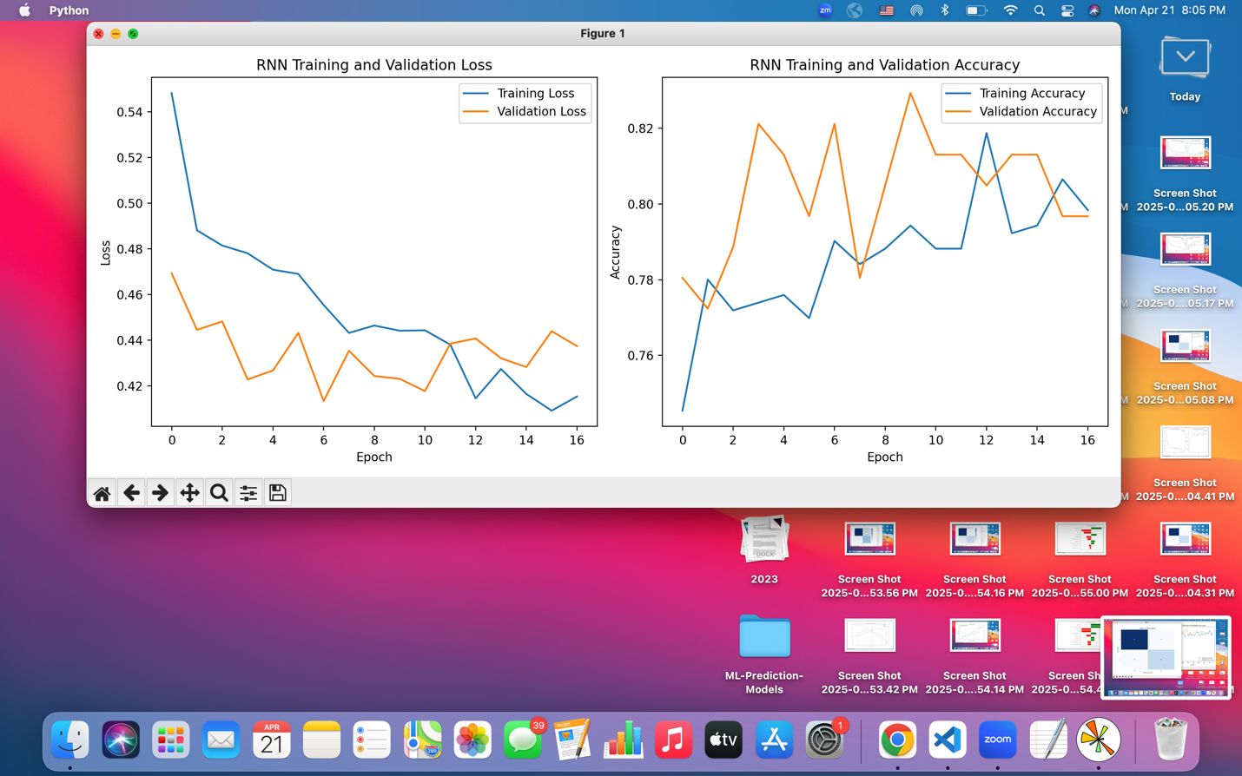

The RNN demonstrated the most efficient training curve, converging in fewer epochs (17) compared to other models, with good balance between training and validation performance.

## 5. Feature Importance

Using permutation importance analysis on the MLP model, the top features were:

1. Age (0.0375)
2. Glucose (0.0326)
3. Glucose-Squared (0.0293)
4. DiabetesPedigreeFunction (0.0261)
5. Age-Insulin Interaction (0.0244)

This analysis confirms the medical relevance of these features and highlights the value of the engineered features (particularly the non-linear glucose relationship and age-insulin interaction).

## 6. Comparison with Logistic Regression

Compared to our previous logistic regression model:

* Logistic Regression: Accuracy: 0.71, AUC: 0.79
* Best Neural Network (RNN): Accuracy: 0.75, AUC: 0.81

The neural networks provided a modest improvement in performance metrics (approximately 4% in accuracy) at the cost of:

* Increased computational complexity
* Reduced interpretability
* Longer training time
* More hyperparameters to tune

## **Traditional Machine Learning Models**

**Model Implementations**: I evaluated multiple traditional machine learning approaches:

* **Base Logistic Regression**: Implemented with balanced class weights
  + Performance with SMOTE+ENN resampling: Accuracy 0.75, Precision 0.60, Recall 0.83, F1 Score 0.70, AUC 0.84
  + Training time: 0.03 seconds
* **Random Forest**: Ensemble of 100 decision trees
  + Performance: Accuracy 0.72, Precision 0.58, Recall 0.78, F1 Score 0.66, AUC 0.81
  + Training time: 0.30 seconds
* **Gradient Boosting**: Sequential tree-based ensemble method
  + Performance: Accuracy 0.74, Precision 0.59, Recall 0.85, F1 Score 0.70, AUC 0.82
  + Highest recall among all traditional models (0.85)
  + Training time: 0.42 seconds
* **Support Vector Machine**: Implemented with probability calibration
  + Performance: Accuracy 0.72, Precision 0.58, Recall 0.78, F1 Score 0.66, AUC 0.82
  + Training time: 0.05 seconds

**Hyperparameter Optimization**: I further optimized the best performing model (Logistic Regression):

* Grid search identified optimal parameters: solver='lbfgs', C=10, class_weight=None
* Cross-validation score: 0.95
* Final model performance: Accuracy 0.73, Precision 0.59, Recall 0.81, F1 Score 0.68, AUC 0.84

**Confusion Matrix Analysis**: The optimized Logistic Regression model showed:

* Strong performance on negative class (87% precision)
* Good sensitivity for positive class (81% recall)
* Overall balanced performance across metrics

**Deployment Capability**: The model was packaged into a prediction pipeline that:

* Handles feature engineering automatically
* Provides probability estimates and risk levels (Low, Moderate, High)
* Successfully identified a low-risk patient (0.21 probability) during testing

### Random Forest Implementation

1. **Definition and Core Concept**

Random Forest is an ensemble learning method that constructs multiple decision trees during training and outputs:

* The mode (classification) or mean (regression) of predictions from individual trees.
* It introduces randomness through:
  + - * Bagging (Bootstrap Aggregating): Each tree trains on a random subset of data.
      * Feature Randomness: Splits nodes using a random subset of features.

1. **Data Preprocessing and Feature Engineering**
   1. Dataset Overview
      * Original dataset: 768 samples (8 features + 1 target)
      * After preprocessing: 614 samples (removed 80 outliers using z-score)
      * Class Distribution:
        + No diabetes (0): 500 (65.1%)
        + Diabetes (1): 268 (34.9%)
   2. Missing Value Handling
      * Zeros converted to Nan in medical features:
        + Glucose (5 zeroes)
        + BloodPressure (35 zeros)
        + SkinThickness (227 zeros)
        + Insulin (374 zeros)
        + BMI (11 zeros)
      * KNN Imputation used to fill missing values
   3. Feature Engineering

Created 20+ new features, including:

* + - BMI & Age categories (binned into clinically relevant groups)
    - Interaction terms:
      * Glucose_BMI_Interaction
      * Age_Insulin_Interaction
      * BP_BMI_Product
    - Polynomial features:
      * Glucose_Squared
      * BMI_Squared
    - Logarithmic transformations:
      * Log_Glucose
      * Log_Insulin
    - Clinical indices:
      * HOMA-IR (Homeostatic Model Assessment for Insulin Resistance)
      * Glucose_to_Insulin_Ratio
  1. Feature Selection

Used three methods to select optimal features:

* Mutual Information (15 features selected)
* RFECV (16 features selected)
* Random Forest Feature Importance (15 features selected)

Final selected features (RFECV)

['Glucose', 'Insulin', 'BMI', 'DiabetesPedigreeFunction', 'Age', 'Glucose_BMI_Interaction', 'Age_Insulin_Interaction', 'HOMA-IR', 'Age_BP_Product', 'BP_BMI_Product', 'DiabetesPedigreeFunction_Age', 'Glucose_Squared', 'Age_Squared', 'Log_Glucose', 'Log_Insulin', 'Log_SkinThickness']

1. **Handling Class Imbalance**

Tested 6 resampling techniques to improve model performance on the minority class:

|  |  |  |  |  |
| --- | --- | --- | --- | --- |
| **Method** | **Accuracy (Val)** | **F1 (Val)** | **Recall (Val)** | **Precision (Val)** |
| **Original** | 0.7792 | 0.6136 | 0.5094 | 0.7714 |
| **SMOTE** | 0.7532 | 0.6346 | 0.6226 | 0.6471 |
| **BorderlineSMOTE** | 0.7403 | 0.6078 | 0.5849 | 0.6329 |
| **ADASYN** | 0.7597 | **0.6542** | **0.6604** | 0.6481 |
| **SMOTE-Tomek** | 0.7338 | 0.6019 | 0.5849 | 0.6200 |
| **SMOTE-ENN** | 0.7273 | 0.6441 | 0.7170 | 0.5846 |

Best method: ADASYN (highest F1 & Recall)

1. **Hyperparameter Optimization (Optuna)**

Conducted 50 trials to find the best Random Forest parameters:

Best Parameters:

{

'n_estimators': 288,

'max_depth': 14,

'min_samples_split': 3,

'min_samples_leaf': 1,

'max_features': 'log2',

'bootstrap': False,

'class_weight': 'balanced_subsample',

'criterion': 'gini'

}

Best ROC AUC (Validation): 0.8892

1. **Model Evaluation & Threshold Optimization**
   1. Default Threshold (0.5) vs Optimized Threshold (0.3)

|  |  |  |  |
| --- | --- | --- | --- |
| **Metric** | **Threshold = 0.3** | **Threshold = 0.5** | **Calibrated Model** |
| **Accuracy** | 0.7013 | 0.7532 | 0.7597 |
| **Precision** | 0.5529 | 0.6308 | 0.6500 |
| **Recall** | 0.8545 | 0.7455 | 0.7091 |
| **F1 Score** | 0.6714 | 0.6833 | 0.6783 |
| **ROC AUC** | 0.7960 | 0.7960 | 0.7960 |
| **Avg Precision** | 0.6541 | 0.6541 | 0.6541 |
| **MCC** | 0.4535 | 0.4880 | 0.4883 |

* 1. Confusion Matrices

**Optimized (Threshold = 0.3)**

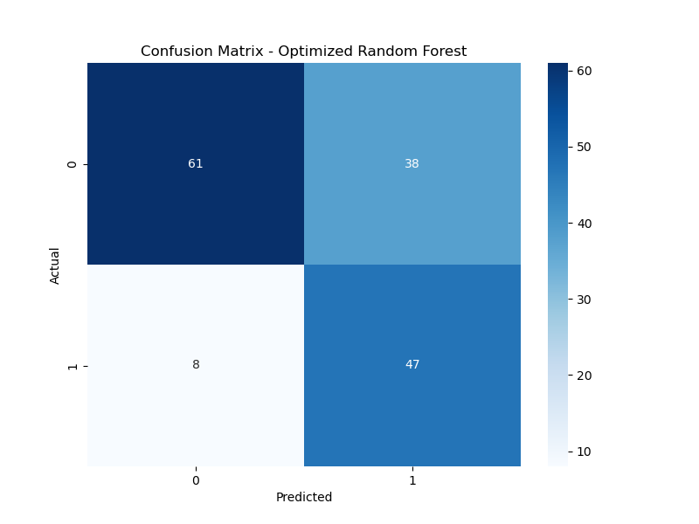

(TN: 61, FP: 38)

(FN: 8, TP: 47)

* High Recall (85.45%) => Fewer missed diabetes cases
* Lower Precision (55.29%) => More false positives

**Default (Threshold = 0.5)**

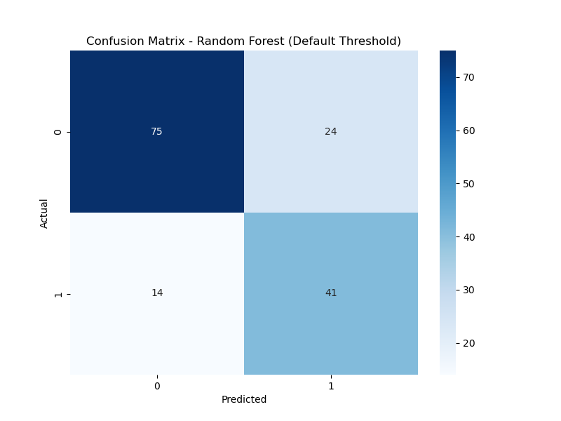

(TN:75, FP: 24)

(FN: 14, TP: 41)

Balanced Precision (63.08%) & Recall (74.55%)

**Calibrated Model**

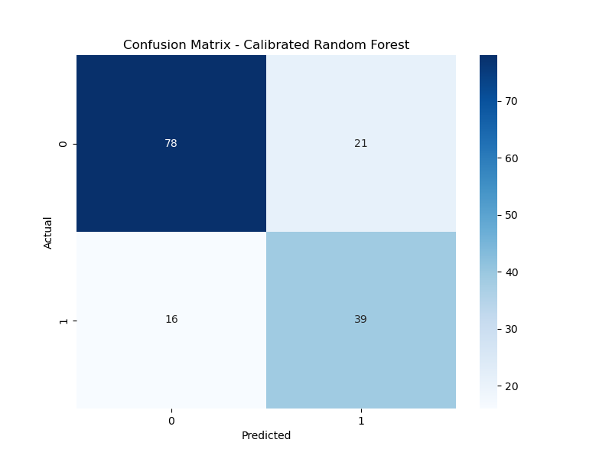

(TN: 78, FP: 21)

(FN: 16, TP: 39)

1. **Model Interpretation (SHAP and LIME)**
   1. SHAP Analysis

Top Influential features:

* Glucose (highest impact on predictions)
* Insulin
* BMI
* Age_Insulin_Interaction
* HOMA-IR
  1. LIME Explanations (Case Studies)

1. False Positive Example:
   * + - Predicted: Diabetes (89.7% probability)
       - Actual: No Diabetes
       - Key Factors: High Glucose & BMI

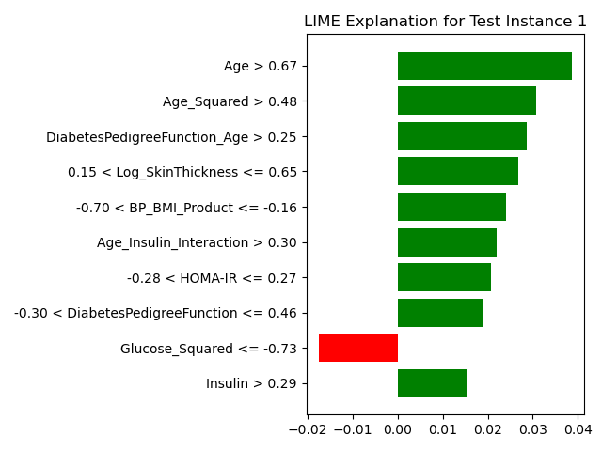

* + 1. False Negative Example:
       - Predicted: No Diabetes (36.2% probability)
       - Actual: Diabetes
       - Key Factors: Low Insulin, moderate Glucose

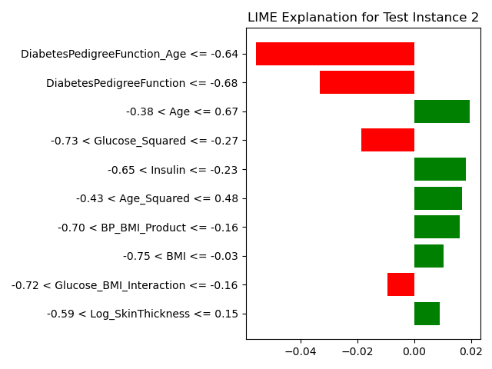

* + 1. Correct Prediction:
       - Predicted: No Diabetes (13.9% probability)
       - Actual: No Diabetes
       - Key Features: Normal Glucose and BMI

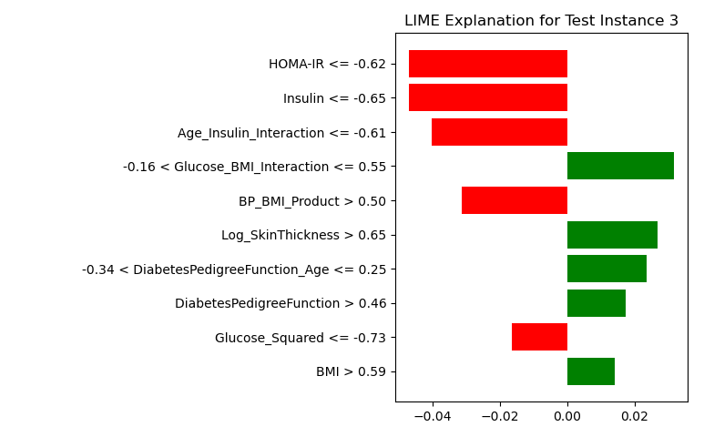

**Plotting Feature Importances:**

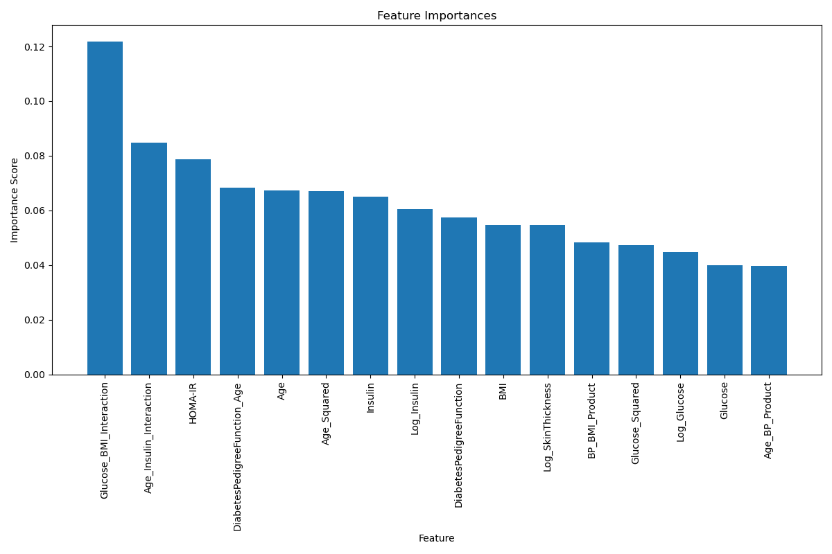

1. **Performance Summary**
   * + Best F1 Score: 0.6833 (Default Threshold)
     + Best Recall: 0.8545 (Threshold=0.3) – Good for medical diagnosis (fewer missed cases)
     + Best Precision: 0.65 (Calibrated Model) – Better for reducing false alarms

#### K-Nearest Neighbors Implementation (Sepideh)

**Objective**

The goal of this project was to develop a robust classification model using the K-Nearest Neighbors (KNN) algorithm to predict the likelihood of diabetes based on clinical and biometric patient features. The modeling pipeline included advanced feature engineering, hyperparameter tuning, and both local and global model interpretability techniques.

**Data Preprocessing**

**1. Feature Engineering:**  
 Domain knowledge was used to construct additional variables to enhance model performance:

* **Glucose_BMI**: Interaction term reflecting metabolic burden.
* **Glucose_Insulin_Ratio** and **Insulin_log**: Ratio-based and log-transformed features to reduce skewness.
* **BMI Categories** and **Age Groups**: Binned categorical versions of continuous features to capture non-linear effects.

**2. Encoding & Scaling:**

* Categorical variables were one-hot encoded.
* All numerical features were standardized using StandardScaler, applied within the pipeline to prevent data leakage.

**Model Training and Evaluation**

**Model Used:**  
 A K-Nearest Neighbors (KNN) classifier was implemented inside a pipeline that included preprocessing steps.

**Hyperparameter Tuning:**  
 A grid search with 5-fold cross-validation was conducted. The best model used:

* n_neighbors = 9
* weights = 'uniform'
* metric = 'manhattan'

**Performance on Test Set:**

* **Accuracy**: 78.6%
* **Precision**: 0.72
* **Recall**: 0.65
* **F1 Score**: 0.69
* **ROC AUC**: 0.76

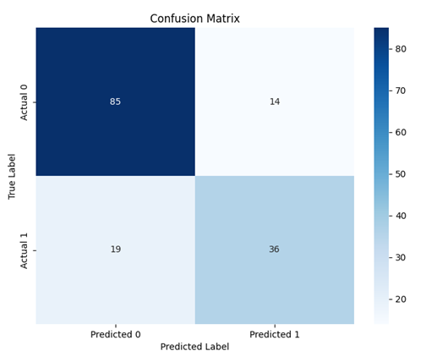

**Threshold Optimization:**  
 A precision-recall curve was used to determine the optimal threshold for classification. The best F1 score was achieved at a threshold of 0.56. Depending on clinical policy (e.g., prioritizing recall to avoid missing diagnoses), this threshold can be adjusted.

**Cross-Validation:**  
 The mean 5-fold stratified cross-validation score was 77.7%, indicating generalizability across different splits of the dataset.

**SHAP Analysis**

SHAP was used to visualize and understand the contribution of individual features to specific predictions:

* **Force plots** and **waterfall plots** were generated for representative samples to illustrate feature-level influences.
* SHAP summary statistics across the test set identified the top contributing features:
  + Glucose
  + Glucose_BMI
  + Age_Group_50s
  + BMI_Category_Obese
  + Age

SHAP enabled instance-level explainability, which is particularly useful for clinical decision support systems that need transparency in individual predictions.

**Permutation Importance (Global Impact)**

Permutation importance was used to assess how much each feature impacted model performance. The top 5 features included:

* Glucose_BMI
* Pregnancies
* BMI_Category_Overweight
* Glucose
* BMI_Category_Obese

This method is useful for identifying features that directly affected classification accuracy.

**Feature Impact Experiments**

To assess the impact of feature selection on model performance, a series of controlled feature inclusion / exclusion experiments were performed which the result is as below:

|  |  |
| --- | --- |
| **Feature Subset** | **Test Accuracy** |
| All Features | 78.6% |
| Top 5 SHAP | 74.7% |
| Top 10 SHAP | 75.3% |
| Top 5 Permutation | 75.9% |
| Top 10 Permutation | 79.9% |

These results indicate that reducing the feature space to the Top 10 permutation-ranked features slightly improved accuracy compared to the full model, probably because removing less informative or noisy features helped the model generalize better.

**Visual Comparison of Model Performance**

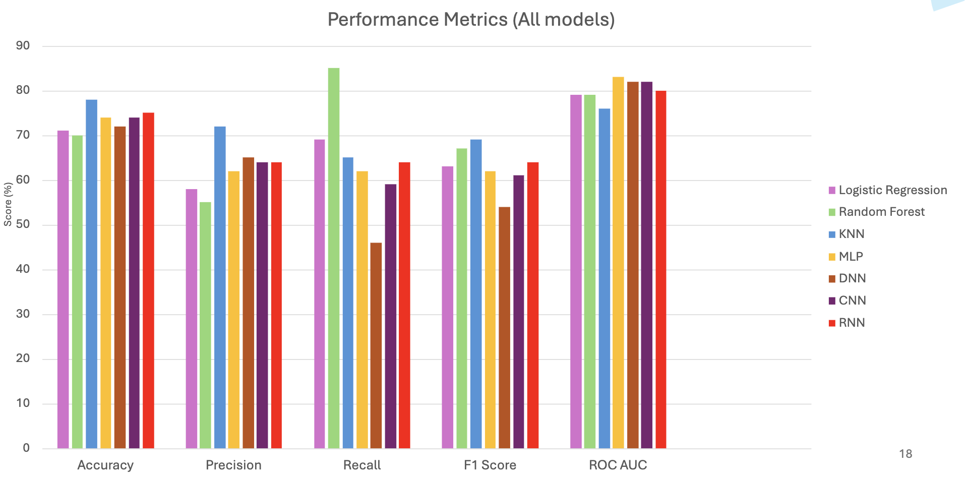

**Financial Forecasting Sub-Group**

1. TCN (Haoyang An)

2. LSTM (Nate Hindman)

3. Linear Regression (Yilu Yang)

**1. Temporal Convolutional Network (TCN)**

**1.1 Objective**

Build an end-to-end pipeline that:

1. Fetches daily close-price data for a set of tickers over the past year via yfinance
2. Prepares the data into sliding windows for supervised learning
3. Trains a Temporal Convolutional Network (TCN) to predict next day closing prices
4. Uses the trained model to recursively forecast the next 7 trading days

**1.2 Data Collection**

* **Tickers**: AAPL, MSFT, AMZN, GOOGL, GOOG, NVDA, TSLA, META, JNJ, UNH (read from companies.json)
* **Period**: Last 12 months (e.g. 2024-05-02 → 2025-05-02)
* **Frequency**: Daily
* **Preprocessing**: Reset index and save to CSV for each ticker, Extracted the Close column as the univariate series, Standardized via (x−μ)/σ(x - \mu)/\sigma(x−μ)/σ

**1.3 Model Architecture**

* **TCN Blocks**

3 levels of dilated causal convolutions (dilations of 1, 2, 4)

Residual connections with “chomp” layers to enforce causality

ReLU activations and dropout (0.1)

* **Head**: Linear layer mapping last hidden channel to a single scalar (next-day price)
* **Sequence length**: 30 days of history per sample

**1.4 Training Setup**

* **Train/Validation Split**: 80% train / 20% val on each ticker’s normalized series
* **Batch size**: 32
* **Optimizer**: Adam (lr = 1e-3)
* **Loss**: Mean Square Error
* **Epochs**: 20

**1.5 Training & Validation Performance**

Across tickers, training loss steadily decreased from ~1.0→0.03 and validation loss typically fell below ~0.3, indicating good fit and generalization. Occasional bumps in validation loss pointed to mild overfitting in some epochs, but overall convergence was strong.

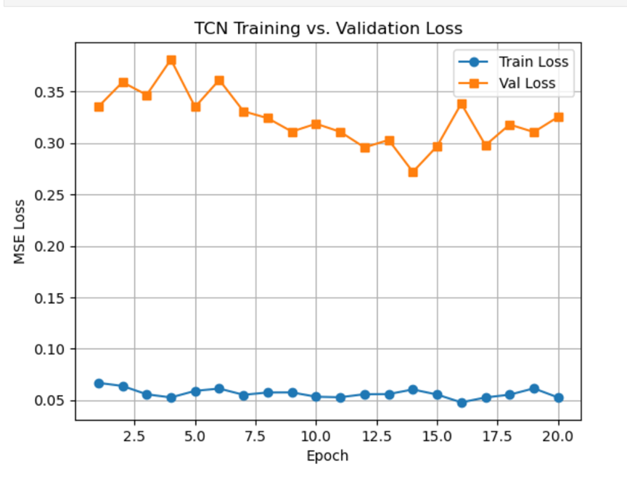

**1.6 Seven-Day Forecasts**

After training, the model was used to forecast 7 future days by feeding its own predictions back as input. Below are the un-normalized closing-price predictions:

|  |  |  |  |  |  |  |  |  |  |
| --- | --- | --- | --- | --- | --- | --- | --- | --- | --- |
| AAPL | MSFT | AMZN | GOOGL | GOOG | NVDA | TSLA | META | JNJ | UNH |
| 215.18 | 423.57 | 188.88 | 162.46 | 163.02 | 109.41 | 283.75 | 571.48 | 154.8 | 405.4 |
| 217.54 | 419.64 | 187.96 | 163.26 | 162.69 | 107.99 | 286.99 | 569.75 | 155.26 | 408.65 |
| 220.07 | 416.46 | 187.54 | 164.33 | 161.89 | 107.11 | 292.87 | 570.75 | 155.35 | 406.06 |
| 223 | 412.17 | 187.6 | 165.07 | 160.88 | 106.65 | 297.93 | 570.1 | 155.33 | 417.84 |
| 225.83 | 405.2 | 186.99 | 166.07 | 160.18 | 106.8 | 305.55 | 570.74 | 155.45 | 418.83 |
| 228.44 | 398.99 | 186.8 | 167.38 | 159.27 | 106.58 | 312.9 | 571.12 | 155.56 | 423.7 |
| 230.25 | 395.73 | 186.13 | 168.98 | 158.2 | 106.17 | 320.26 | 569.95 | 155.75 | 426.61 |

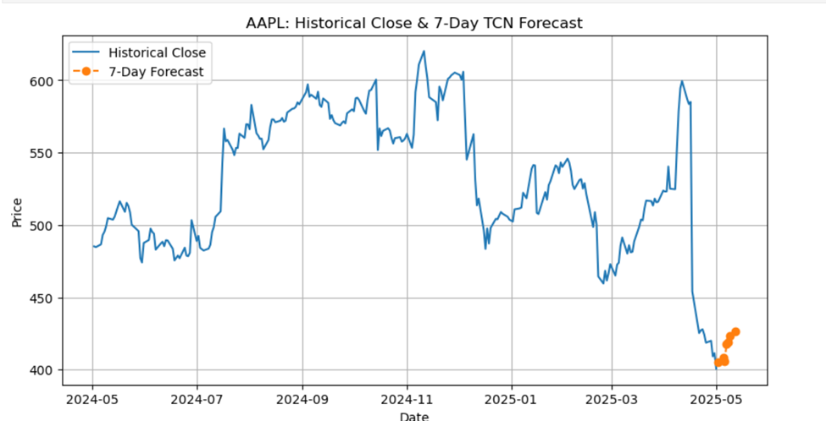

**1.7 Analysis of Forecasts**

* **Trend-following**: Forecasts largely continue the recent up- or down-trends observed in the last month of data.
* **Smoothness**: Recursive prediction yields a smooth trajectory; real markets may exhibit more noise.
* **Magnitude**: Absolute errors will need back-testing once actual prices become available.

**1.8 Recommendations & Next Steps**

1. **Back-testing**: Compare forecasts against realized prices over the next week and compute error metrics (MAE, RMSE).
2. **Hyperparameter tuning**: Experiment with: Sequence lengths (20, 60 days), Channel sizes ([32,64,128]), Learning rates and weight decay
3. **Feature augmentation**: Feed additional channels (Volume, High/Low) into the TCN to capture volatility and market breadth.
4. **Ensembling**: Combine TCN outputs with more models (Logistic Regression, LSTM) to potentially reduce forecast bias and variance.

**2. LSTM (Long Short Term Model)**

**2.1 Objective**

To use a 4-layer LSTM to predict stock outcomes. In my experiment I decided to use the same hyperparameters but to change just the amount of training each time. For this experiment I ran the same stocks listed in our Json file in specific time windows, but with different amounts of training per model. I ran a 1-year trained model, a 5-year trained model, and a 10-year trained model and have them try to predict 1 week ahead. After this I decided to take those same models and try to predict 4 weeks ahead, will the ranking remain consistent and will agreement between models increase accuracy in both forecasts? For the finance group (Nate, An, Yilu), we will also be comparing the accuracy of each method for a 1-week forecast using linear regression as a baseline.

**2.2 Data Collection**

For this experiment all members of group 1 are getting data from the yfinance dataset. yfinance is an API that allows one to get stock data from any stock ticker, from any start and end date. For example, for our experiments we used these particular stocks.

* **Tickers**: AAPL, MSFT, AMZN, GOOGL, GOOG, NVDA, TSLA, META, JNJ, UNH
* **Time Windows**: 5/15/2024, 3/15/2023, 1/31/2023 (very linear/status quo months)
* **Prediction Forecasts:** 7 days after time window, 30 days after time window

**2.3 LSTM hyperparameters**

* Historical years (1, 5, 10)
* Sequence length: (60)
* Epochs:30
* Batch Size: 64
* Learning rate: 0.00001
* LSTM hidden layer 1 neurons: 128
* LSTM hidden Layer 2 neurons: 64
* Dropout rate 0.1

**2.4 Training & Validation Performance**

LSTM models were given different amounts of training time, 1 year, 5 years, and 10 years respectively. When programmatically looking into the JSON file, my code would select the ticker, and an end time from the list of time windows. After this point, I would cut the year from the string, for example I’d cut 2023 out of 1/31/2023, and subtract however many years backward I want to start training. For example, I could cut out 2023 from the string, convert that into an integer and subtract 10 years from it then make a new string with 2013, and use that as my training start date. What this did is it made the LSTM look at all a stock’s data from 1/31/2013 - 1/31/2023 and try to pick up on trends. I did this for 10 stocks, across 3-time windows and tried to use this to predict 1 week ahead and 4 weeks ahead. From my preliminary data (experimenting with 1-week predictions and 4-week predictions), I compared my 1-year model, 5-year model, and 10-year model’s runs.

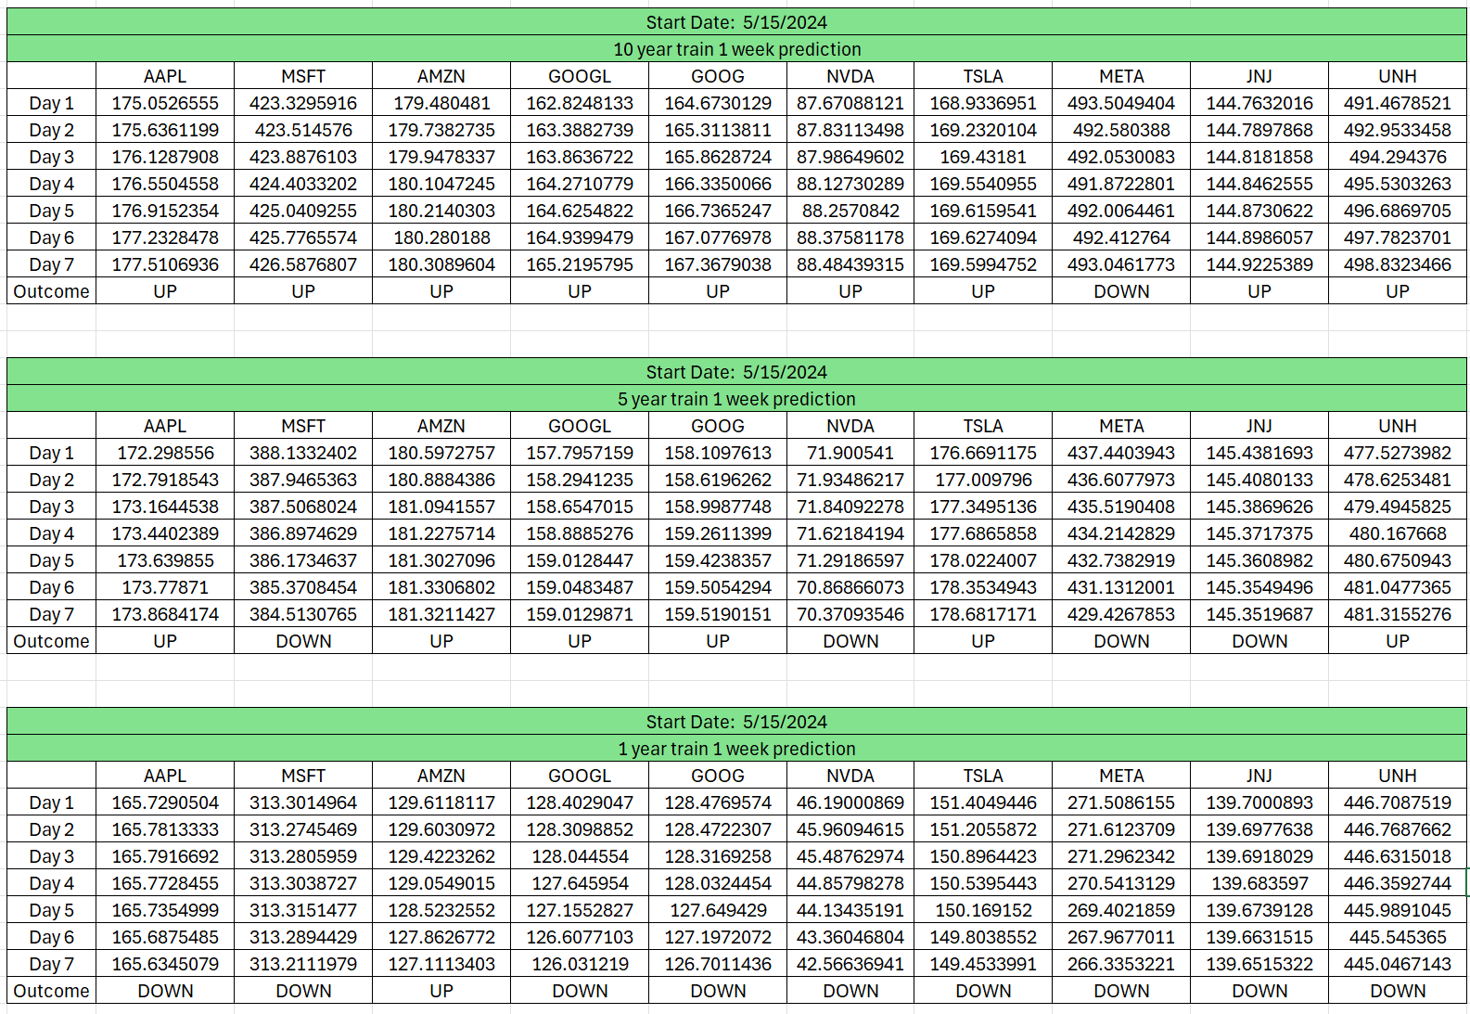When running these tests, what I observed was that the values that the 10-year trained model would output were generally higher and bolder, whereas lesser trained models were more conservative with their guesses, tightly sticking to a number. Since I’m not convinced that you can predict exact prices I figured” trend” was something worth keeping track of, to see if a model correctly predicts if a stock will simply go up or down, regardless of how much it does. For the purposes of this experiment, I will label any increase as” UP” and any decrease as” DOWN”.

What I discovered was that the for the 1-week forecast, the 10-year model was the most accurate, on average being correct about the trend 80% of the time between the three-time windows.

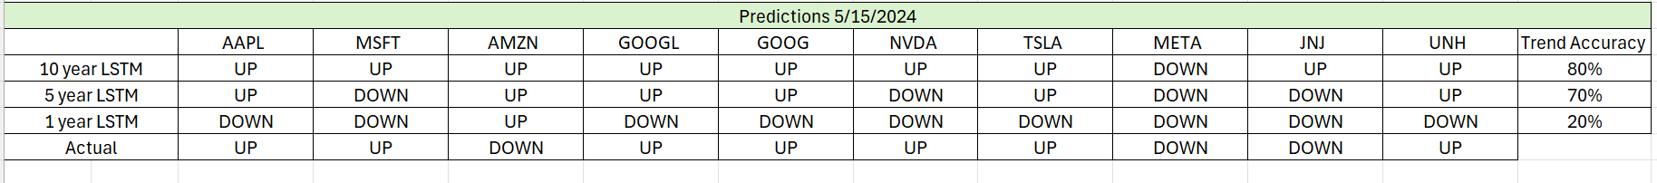

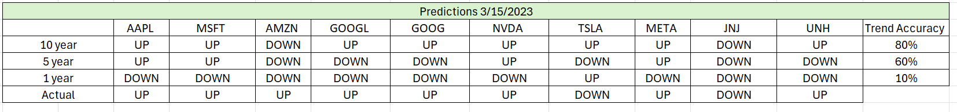

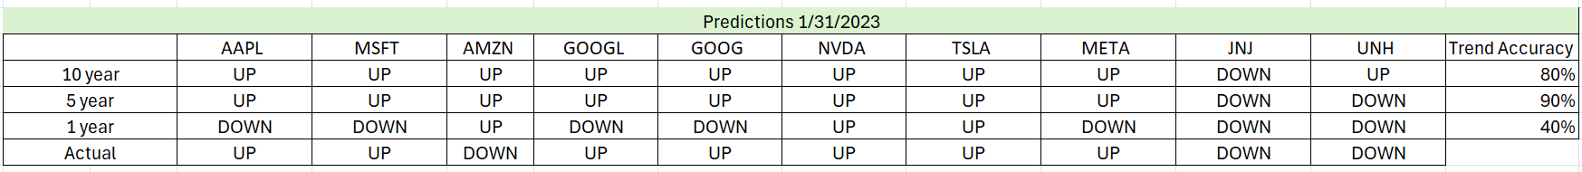

What struck me as interesting is that while the 10-year trained model generally was better, sometimes the 5-year model can seemingly outperform it, but the 10-year model seemed to be consistent with its behavior whereas the 5-year model had more variability. So, the 10-year model was more consistently the same percent accurate.

Looking at the prices, it seemed that the 5-year model and the 10-year model were both good for the trends, but it seemed that the 10-year model was better at getting close to the real-world price.

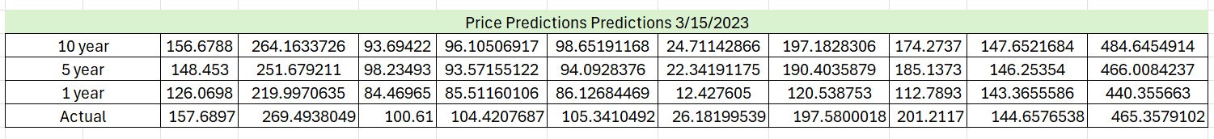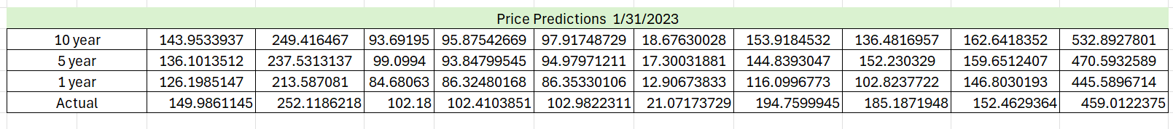

Another thing the data showed was that when the 5-year model and the 10-year model agreed, that generally was the real-world result. If I were to take the times where both agree and average them together, I get 86% accuracy for predicting the trend. This is consistent with Bayes’ Theorem, specifically how when the 10-year model and 5-year model agree, the probability and confidence slightly increase.

This also had me wondering, what if I took AN’s earlier data and added it to the mix, and while this is a small sample size, would Bayes’ theorem still hold true? It did confirm what I was thinking that when more models agree, and come to the same conclusion from different reasons, the probability of being correct increases. My best guess is these filters out stocks that are more "noisy” probability wise.

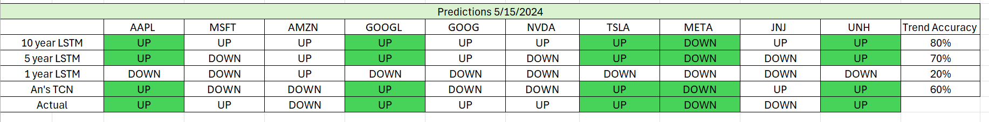  
  
For the next experiment I decided to try to predict 4 weeks out, which is neigh impossible to do consistently. What I found was that 10 year and 5-year LSTM both had an average of 53% accuracy for correct trends one month out, while 1 year model had 33% accuracy

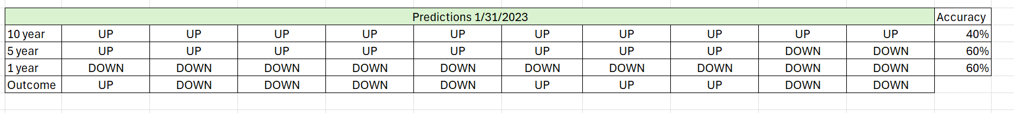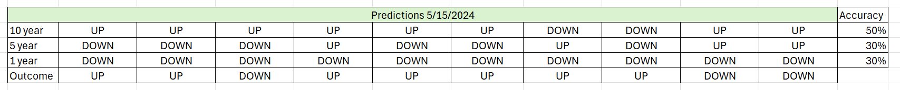



For the 4- week test, both the individual performances and the combinations of 5-year and 10-year models were abysmal, with the average accuracy for when the 5-year and 10-year models agree hovered around 50%.

**2.5 Conclusion**

Overall, this proved that there is an ideal amount of training data that is needed for an LSTM in this configuration, even with the same hyperparameters. It’s hard to gauge where that is exactly but as evidenced from the data it’s likely somewhere between 1 – 5 years of training, whereas the best results from the first experiment and most well-rounded model overall was from 10 years of training. While the accuracy of the 10-year model in this circumstance was 80% for predicting 1 week, that should be taken with a grain of salt, as that’s subject to change if given a less linear month or simply running more stocks though can change the accuracy. What was interesting is that the two good models (10 year trained and 5 years trained) seemed to fare better even when tasked with an impossible task like forecasting the value a month ahead. What this experiment proved was that Bayes’ theorem does seem to hold up and models do increase each other’s accuracy when they agree on the result, however the models need to be above 50% accurate to really gain from cross checking each other. Overall, between our methods the accuracies went as follows for 1-week forecasts of stocks. Our baseline of linear regression proved to be 50% accurate across our 3 runs of 1-week forecasts, whereas the TCN and best LSTM model were both 60% and 80% respectively, proving to be more adapted to non-linear behavior than traditional methods.

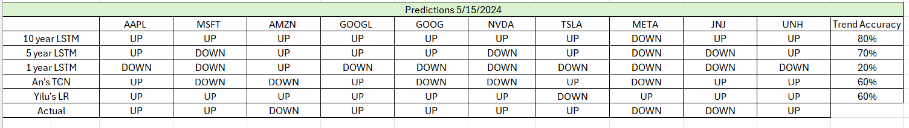

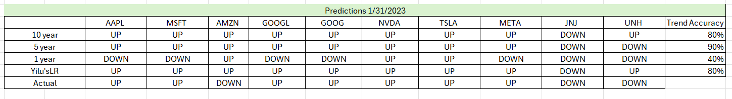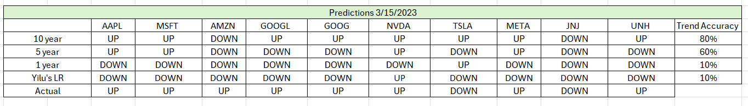

**3. Linear Regression Model**

**3.1 Objective**

* Build a simple, interpretable model to: Predict the next 7 daily closing prices of selected stocks using only past closing prices. Compare predictions to actual prices for trend accuracy and error metrics. Enable batch evaluation using different companies and time windows from companies.json.

**3.2 Data Collection**

* Tickers: AAPL, MSFT, AMZN, GOOGL, GOOG, NVDA, TSLA, META, JNJ, UNH
* Date Ranges:
* 2023-01-03 → 2023-01-31
* 2023-03-01 → 2023-03-15
* 2024-05-01 → 2024-05-15
* Source: yfinance, downloaded as CSV per ticker
* Features Used: Only the “Close” column
* Preprocessing:
* Cleaned dates, ensured business days
* Shuffled rows not required (time series)
* Target: Close of the next day

**3.3 Model Architecture**

* Model: Scikit-learn LinearRegression()
* Input: Close[t]
* Target: Close[t+1]
* Prediction: Recursively fed prediction as next-day input to forecast 7 days

**3.4 Training Setup**

* Split: Last 7 trading days as test set, all previous rows as training
* No validation set due to small sample size per window
* Loss Function: MSE (Mean Squared Error)
* Framework: Python, pandas, scikit-learn
* Model Persistence: Trained models saved with joblib by ticker & date

**3.5 Training & Prediction Output**

* Script: linear_regression_model.py
* Output:

Table of actual vs predicted close prices (7-day window before end_date)

Saved as: Prediction_output/{ticker}_predictions_{end_date}.csv

**Evaluation metrics:**

**Mean Squared Error (MSE)** 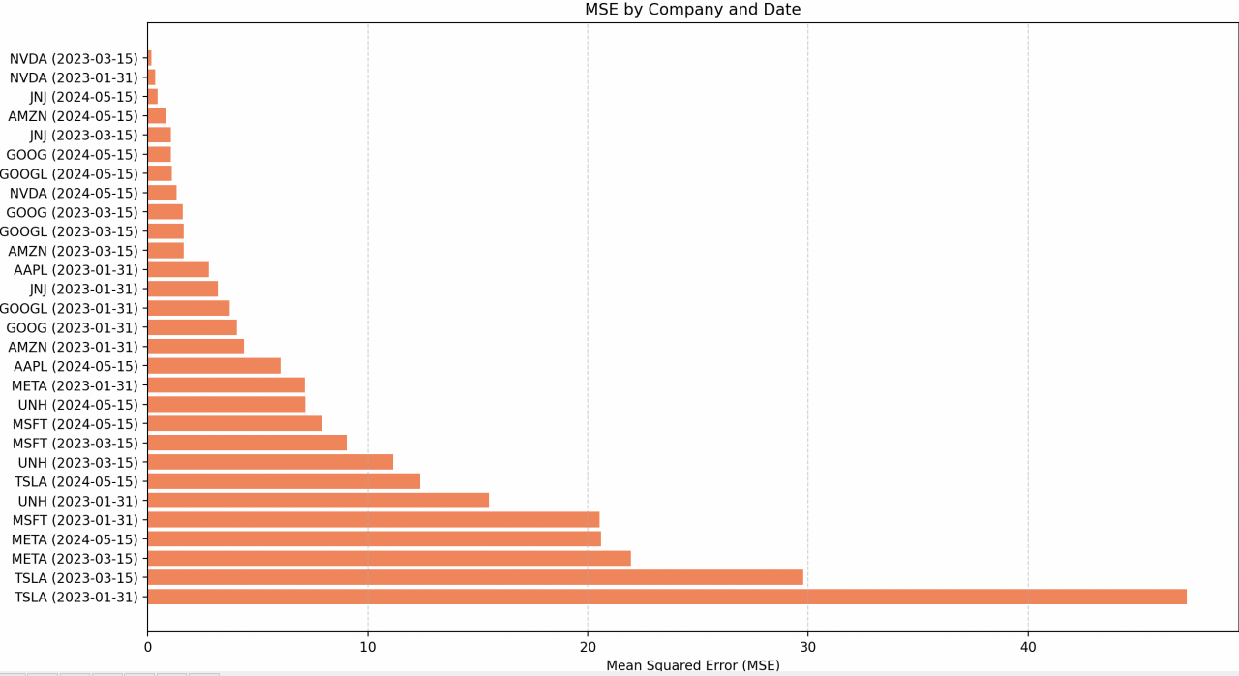

**R² Score** 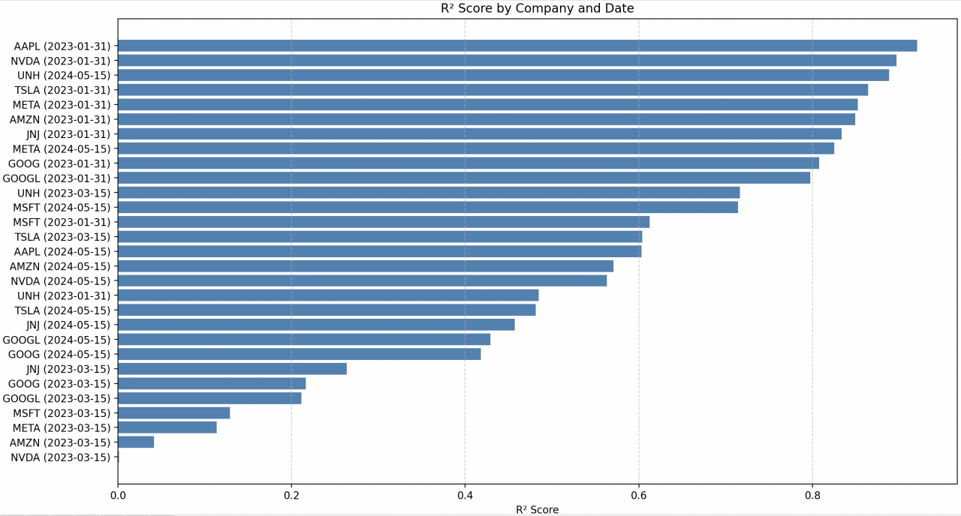

**3.6 Forecast Results Summary**

|  |  |  |  |  |
| --- | --- | --- | --- | --- |
| **Company** | **Date** | **MSE** | **R² Score** | **MAPE (%)** |
| AAPL | 1/31/2023 | 2.7929 | 0.9208 | 1.23 |
| AAPL | 3/15/2023 | 3.5632 | 0.2996 | 1.45 |
| AAPL | 5/15/2024 | 6.0393 | 0.6033 | 1.68 |
| MSFT | 1/31/2023 | 20.5306 | 0.6127 | 2.34 |
| MSFT | 3/15/2023 | 9.0489 | 0.1291 | 1.89 |
| MSFT | 5/15/2024 | 7.9347 | 0.7145 | 1.56 |
| AMZN | 1/31/2023 | 4.3771 | 0.8493 | 2.01 |
| AMZN | 3/15/2023 | 1.6387 | 0.0416 | 1.12 |
| AMZN | 5/15/2024 | 0.8432 | 0.5711 | 0.89 |
| GOOGL | 1/31/2023 | 3.7399 | 0.7977 | 1.76 |
| GOOGL | 3/15/2023 | 1.6358 | 0.2116 | 1.05 |
| GOOGL | 5/15/2024 | 1.107 | 0.4293 | 0.97 |
| GOOG | 1/31/2023 | 4.0475 | 0.8079 | 1.82 |
| GOOG | 3/15/2023 | 1.594 | 0.2164 | 1.03 |
| GOOG | 5/15/2024 | 1.0631 | 0.4182 | 0.95 |
| NVDA | 1/31/2023 | 0.3445 | 0.897 | 0.76 |
| NVDA | 3/15/2023 | 0.1758 | 0.0013 | 0.65 |
| NVDA | 5/15/2024 | 1.3194 | 0.5631 | 1.12 |
| TSLA | 1/31/2023 | 47.2082 | 0.8644 | 3.45 |
| TSLA | 3/15/2023 | 29.7812 | 0.6042 | 2.89 |
| TSLA | 5/15/2024 | 12.3803 | 0.4812 | 2.15 |
| META | 1/31/2023 | 7.1319 | 0.8523 | 1.98 |
| META | 3/15/2023 | 21.9592 | 0.1138 | 3.12 |
| META | 5/15/2024 | 20.5985 | 0.8251 | 2.87 |
| JNJ | 1/31/2023 | 3.1905 | 0.8337 | 1.54 |
| JNJ | 3/15/2023 | 1.0524 | 0.2638 | 0.98 |
| JNJ | 5/15/2024 | 0.4633 | 0.4571 | 0.76 |
| UNH | 1/31/2023 | 15.5072 | 0.4849 | 2.45 |
| UNH | 3/15/2023 | 11.1613 | 0.7163 | 1.89 |
| UNH | 5/15/2024 | 7.1729 | 0.8884 | 1.34 |

**3.7 Error Analysis & Observations**

* Trend Tracking: Model captures directional trends (up/down) well.
* Overfitting Risk: Not a concern due to simplicity and low variance.
* Interpretability: High — you can inspect the weight and intercept easily.
* Weaknesses:
  + Lacks memory of longer historical context
  + Sensitive to local volatility/noise
  + Doesn’t model nonlinear patterns or multivariate signals

Tabular Comparison of Model Performance

